**Vehicle Patrolling for Police:**

As we all know about the busy schedule of our Indian Police, we have come up with a Patrolling device that uses the help of the Botts' dots seen on roads. We plan to put navigating chips in these Botts that helps with the better navigation of our so-called patrolling device. We plan to use Arduino language to program the movement of the Patrolling device.

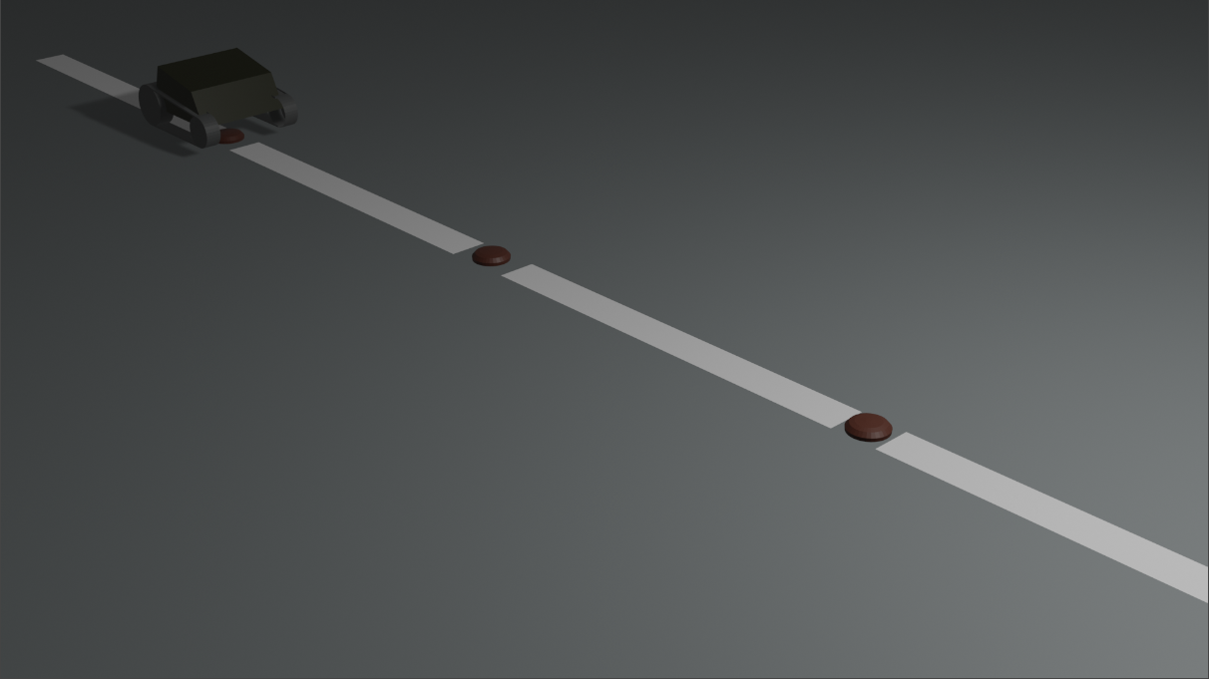

As we can see the above pic, the red dots contain sensors that help with the navigation of the Arduino powered Patrolling device. Now the Patrolling are equipped with High Quality Cameras that give live feed to the police.

This device must be installed at roads where police reach is less so as to prevent unwanted crimes like Rape, Car theft, Murder etc.

